# Project 3-1 Single Image Haze Removal

# Using Dark Channel Prior

Name：Deming Wu(吴德明) StudentID: 2019232111

## 1、Objective

In bad weather such as fog and haze, the quality of the collected image will be severely reduced due to atmospheric scattering, making the image color grayish white, the contrast reduced, and the object features difficult to identify. Therefore, image defogging technology is needed to enhance or repair to improve the visual effect.

The current image defogging methods can be divided into two main categories: (1) Enhancement methods based on image processing. This method improves image quality by enhancing foggy images. Its advantage is that it can use the existing mature image processing algorithms for targeted application, enhance the contrast of the image, highlight the features of the scene and valuable information in the image; the disadvantage is that it may cause the loss of part of the image information and distort the image. (2) Restoration methods based on physical model. This method studies the scattering of light by atmospheric suspended particles, establishes an atmospheric scattering model, understands the physical mechanism of image degradation, and restores the image before degradation.

This project is based on CVPR2009 best paper -*Single Image Haze Removal Using Dark Channel Prior* from Kaiming He. The method from this paper is one of restoration methods based on physical model.

## 2、Method

### 2.1 Dark Channel Prior

The so-called dark channel is a basic assumption. It is assumed that in most of the non-sky local areas, some pixels will always have at least one color channel with a very low value. This is actually easy to understand. There are many reasons for this assumption in real life, such as shadows in cars, buildings, or cities, or colorful objects or surfaces (such as green leaves, various bright flowers, or blue Color green sleep), darker objects or surfaces, the dark channels of these scenes always become darker. Therefore, the causes of low brightness pixels in the dark channel are mainly the following: (1) Shadows. (2) Colorful objects or surfaces. (3) Dark objects or surfaces.

The proof of dark channel prior is derived from a large number of verifications of the skyless pictures. Figure 1 describes some pictures’ dark channels. The dark channel prior may be invalid when the scene object is inherently similar to the airlight over a large local region and no shadow is cast on the object.

Formally, for an image J, we define

(1)

where is a color channel of J and is a local patch centered at x. The intensity of is low and tends to be zero if J is a haze-free outdoor image and without sky.

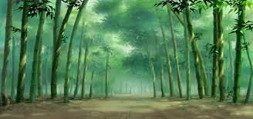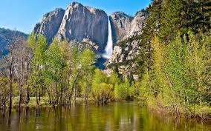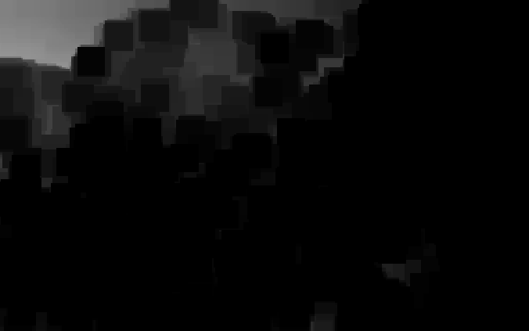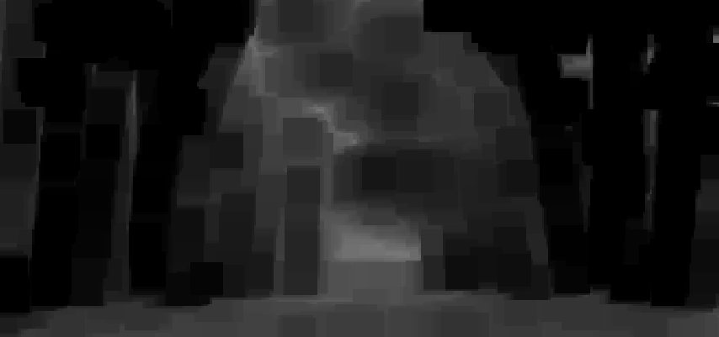

Figure1 Some pictures and their dark channels

### 2.2 Haze Removal Background

In computer vision and computer graphics, the fog map formation model described by the following equations is widely used:

(2)

where I(x) is the observed intensity, J(x) is the scene radiance, A is the global atmospheric light, and *t(x*) is the medium transmission describing the portion of the light that is not scattered and reaches the camera. The goal of haze removal is to recover *J(x), A*, and *t(x)* from *I(x)*. Figure 2 describes a simple imaging model of this. The first term *J(x)t(x)* on the right hand side of Equation (2) is called direct attenuation, and the second term *A(1-t(x))* is called airlight.

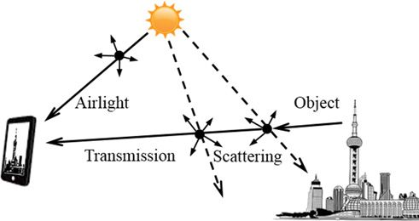

Figure 2 This image describes the parts that are imported into the mobile phone's imaging, which are the images obtained by direct transmission and partial scattering and the light obtained from the global atmospheric light components, finally mixed to form the final image we see.

### 2.3 Haze Removal Using Dark Channel Prior

#### 2.3.1 Estimating the Atmospheric Light

Existing research results show that this airlight can be obtained from haze images. It is proposed in Tan's paper that the brightest pixel of a haze image can be considered a haze-opaque. The reason for this consideration is that when the weather is cloudy, sunlight is usually ignored, in which case airlight is the only source of illumination in the landscape. If there is an image in which there is a pixel at a very long, infinite distance, (at this time, the transmittance of this pixel is almost 0). The pixel with the brightest and brightest value in this image can be regarded as the greatest degree of fog occlusion, and its value can be regarded as almost equal to *A*.

In real operation, the top 0.1% brightest pixels in the dark channel are picked. These pixels are most haze-opaque. Among these pixels, the pixels with highest intensity in the input image *I* is selected as the atmospheric light. If the traditional method is used, the point with the highest brightness value in the image is directly selected as the global atmospheric light value. In this way, white objects in the original haze image will affect this and make its value high. The calculation of the dark channel can erase small white objects in the original image, so the estimated global atmospheric light value will be more accurate.

#### 2.3.2 Estimating the Transmission and Recovering

Equation (2) describes a simple model of imaging from 2.2, and 2.3.1 tells us how to get the atmospheric light value *A.* We can get Equation (3) from Equation (2).

(3)

And we calculate the dark channel depending on Equation (3) and Equation (1). This equation is equivalent to:

(4)

Because the intensity of is low and tends to be zero if J is a haze-free outdoor image and without sky, we can get:

0 (5)

Then, we can estimate the transmission simply by:

(6)

In real life, even in sunny white clouds, there are some particles in the air. Therefore, the effect of haze can be felt when looking at distant objects. In addition, the presence of haze makes humans feel the presence of depth of field. A certain degree of haze is retained when the haze is removed. This can be modified by introducing a factor ω between [0, 1] in Equation (6). When this parameter is 0, it means no haze removal, and when it is 1, it means all haze removal. We usually choose 0.95.

(7)

After the transmission image is obtained, the recovered image can be obtained *J (x)* depending on Equation (8).

(8)

The directly recovered scene radiance *J(x)* is prone to noise. Therefore, we restrict the transmission *t(x)* to a lower bound *t0*. A typical value of *t0* is 0.1.

(9)

### 2.4 Guided Filter

For an input image *p*, the guiding image *I* is used to obtain the output image *q* after filtering, where both *p* and *I* are inputs to the algorithm. Guided filtering defines a linear filtering process as shown below. For the pixel at position *i,* the resulting filtered output is a weighted average:

(10)

Where *i* and *j* represent pixel subscripts, and *W* is filter kernel only related to the guide image *I.* The filter is linear with respect to *p*. we assume guided filtering is that there is a local linear relationship between the output image *q* and the guided image *I* on the filtering window .

(11)

For a certain window with *r* as the radius, () will also be the only constant coefficient determined. This guarantees that in a local area, if the guide image *I* has an edge, the output image *q* also maintains the same edge, because for adjacent pixels, *∇q = a∇I*. So as long as the solution gets the coefficient *a, b* also gets the output *q*. At the same time, it is considered that the non-smooth areas in the input image are not smoothed as noise *n*, and there is . The ultimate goal is to minimize this noise. For each filtering window, the optimization of the algorithm in the least squares sense can be expressed as

(12)

Finally, introducing a regularization parameter ϵ avoid too large, and get the loss function in the filtering window:

(13)

Then, partial derivative of parameters solve optimization process:

(14)

(15)

where , respectively indicate the mean and variance of the guidance image *I* in the window . |*w*| is the number of pixels in window . is the mean of pixels in window Finally, we can get final expression of Equation (11).

（16）

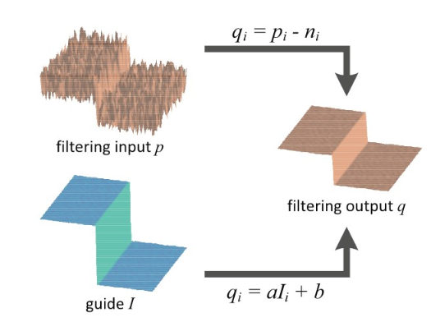 We use transmission map as the filter image and the original image as the guided image depending on guided filter to reﬁne the transmission. Figure 3 simply describes the progress of guided filter.

Figure 3 the progress of guided filter

## C:\Users\W D M 2 0 1 4\AppData\Local\Microsoft\Windows\INetCache\Content.Word\result1.jpg3、Result

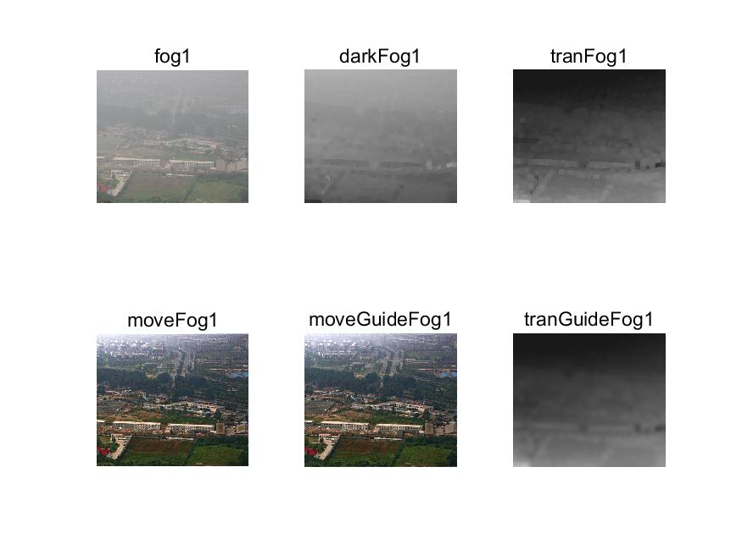

Figure 4 Getting dark channel image uses window’s radius 7, and use 8 as guided filter’s radius.

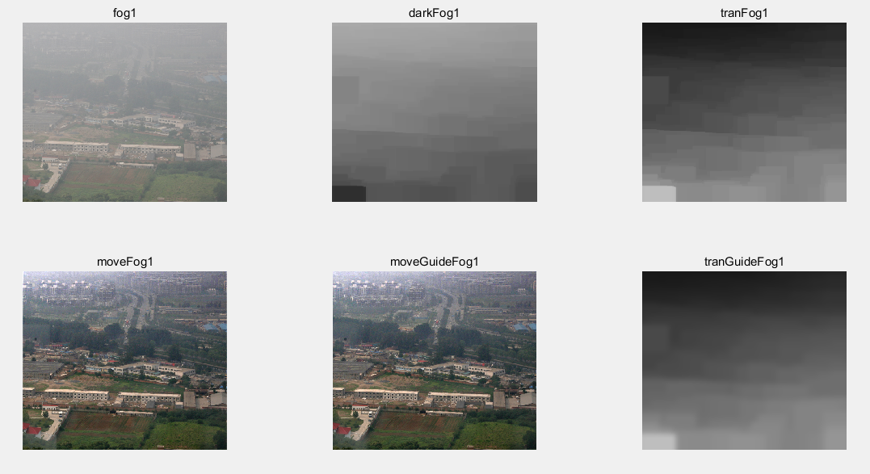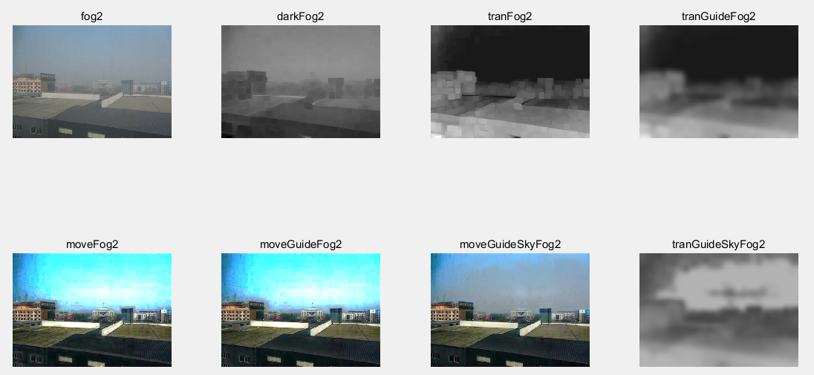Figure 5 Getting dark channel image uses window’s radius 30, and use 8 as guided filter’s radius.

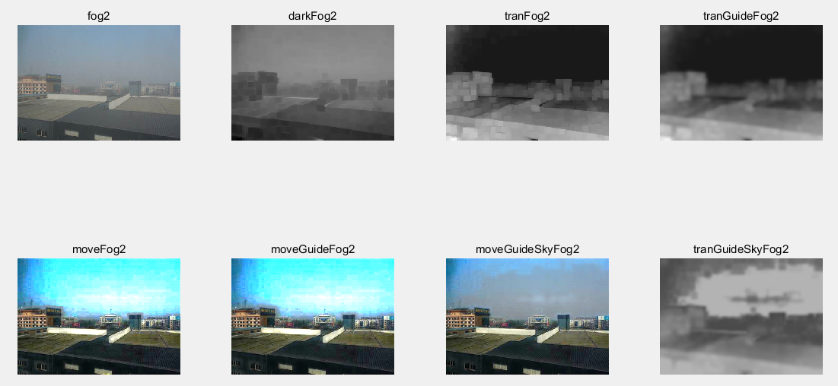Figure 6 Getting dark channel image uses window’s radius 7, and use 8 as guided filter’s radius.

Figure 7 Getting dark channel image uses window’s radius 7, and use 4 as guided filter’s radius.

## 4、Discussion

Dark channel minimum filter radius r has an effect on the haze removal effect. Under certain circumstances, the larger the radius, the less obvious the effect of haze removal. And when the radius becomes larger, the program will run slowly. The influence of is also great. This value is the degree of haze retention we set. The higher the value, the less the haze retained. Guider filter is to make the transmission smoother, so the radius of guided filter can’t be too small. If the radius is small enough, the transmission map will have lots of blocks like Figure 7. is to ensure that Equation (14)’ divisor is not 0. So we should set a little value. The *t0* value is to make sure that transmission map’s value can’t be too small.

The dark channel prior can’t handle the sky area well, so I set a threshold on the pixel value minus the atmospheric light value in my project. It makes the sky area look more normal in Figure 6 and Figure 7.